ESARDA Formatting Guidelines for Authors

First Author Name ^{a,*}, Second Author Name ª, Third Author Name ^{a,b}, Fourth Author Name ^{b}, Fifth Author Name ^{b}
ª University Name, Faculty Group, Department, Street Address, City, Country, Postal Code
^{b} Company Name, Street Address, City, Country, Postal Code

Abstract:
The abstract should contain between 100 and 350 words. A concise and factual abstract is required. The abstract should state briefly the purpose of the research, the principal results and major conclusions. An abstract is often presented separately from the article, so it must be able to stand-alone. For this reason, References should be avoided, but if essential, then cite the author(s) and year(s). Furthermore, non-standard or uncommon abbreviations should be avoided, but if needed they must be defined at their first mention in the abstract itself.

Keywords: Keyword1, Keyword2, Keyword3 (Please select a maximum of 6 keywords)

How to use the template
Using this template will enable you to prepare your paper in accordance with the instructions for authors for the ESARDA Bulletin with a minimal amount of manual styling and formatting.
Please read through the following sections for more information on preparing your paper. However, if you use the template you do not have to worry about setting margins, page size, and column size etc. as the template already has the correct dimensions.

Subsections
Divide your article into clearly defined and numbered sections. Subsections should be numbered 1.1 (then 1.1.1, 1.1.2, ...), 1.2, etc. (the abstract, Acknowledgements, and References are not included in section numbering). Use this numbering also for internal cross-referencing: do not just refer to "the text". Any subsection may be given a brief heading. Each heading should appear on its own separate line.

Format
Text should be produced within the dimensions shown on these pages; each column 8.47 cm wide with 0.85 cm middle margin, total width of 17.78 cm and a maximum length of 21cm on the first page and 23.5cm on the second and following pages. Make use of the maximum stipulated length apart from the following two exceptions: (i) do not begin a new section directly at the bottom of a page, but transfer the heading to the top of the next column; (ii) you may exceed the length of the text area by one line only in order to complete a section of text or a paragraph.
You must use 1.0 (single) line spacing. However, when typing complicated mathematical text it is important to increase the space between the text lines in order to prevent sub- and superscript fonts overlapping one another and making your printed matter illegible. If you are using a desktop publishing program ensure that your auto adjust for interline spacing is suitably set to prevent overlapping but without leaving too much space.
All text should be HelveticaNeue Std LT (Body) with font sizes and pre-set styles as follow: Title 14pt (93 Black Extended), Authors 9pt (63 Medium Extended), Affiliations 9pt (45 Light), Abstract body 10pt italic (46 Light Italic), Keywords 10pt (45 Light), Body text 10pt (45 Light), Level 1 headings 11pt bold (65 Medium), Level 2 headings 10pt (65 Medium), Level 3 headings 10pt (46 Light Italic), Footnotes 8pt. We recommend you use the pre-set styles provided.
If corrections are made to the printout, run off completely new replacement pages. The contrast on these pages should be consistent with the rest of the paper, as should text dimensions and font sizes.

Figures and graphs
All illustrations should be clearly displayed by leaving at least a single line of spacing above and below them. Figures must be of good quality at the highest possible resolution. Blurry, pictures are not permitted. When placing a figure at the top of a page, the top of the figure should be at the same level as the first text line of the other column. Legends to illustrations should be centred if on one line or aligned left if on two or more lines. Figures and graphs should also be large enough for the figure to be clear. Text within figures must be HelveticaNeue Std LT (Body) font, as appropriate for the figure. Font sizes for legends should be 8pt (to be legible). Figure captions should appear below the figure. The captions should be clear and simple, although sufficient information should be provided for the figure to be understood without further reference to the text. Captions should be 9 point HelveticaNeue Std LT font, left aligned with the figure, and have 6pt spacing after and 6pt before the captions. The words “Fig. 1.” should be in bold as shown in the example figure in this document. The caption should end with a full stop. You can also use one column for large figures (see Fig. 2 in the last page of template for submission).
Figure 1. Good quality with clear lettering.

Tables
Tables should have a title, which makes the general meaning understandable without reference to the text. Tables should be presented in the form shown in Table 1, with all text, including title 9pt. Their layout should be consistent throughout. Horizontal lines should be placed above and below table headings, above the subheadings and at the end of the table above any notes. Vertical lines should be avoided. Table borders should be simple ½ point lines (no double or bold lines). The header row of the table should be in bold type, not italic. If a table is too long to fit onto one page, the table number and headings should be repeated on the next page before the table is continued. Alternatively, the table can be spread over two consecutive pages (first on even-numbered, then on odd-numbered page). Table captions should appear above the table. The captions should be clear and simple, although sufficient information should be provided for the table to be understood without further reference to the text. Captions should be 9 point HelveticaNeue Std LT (Body) font, centred with the table, and have 6pt spacing before and 6pt after the captions. The words “Table 1” should be in bold as shown in the example figure in this document. The caption should end with a full stop. You can also use one column for large tables (see Table 2 in the last page of template for submission).
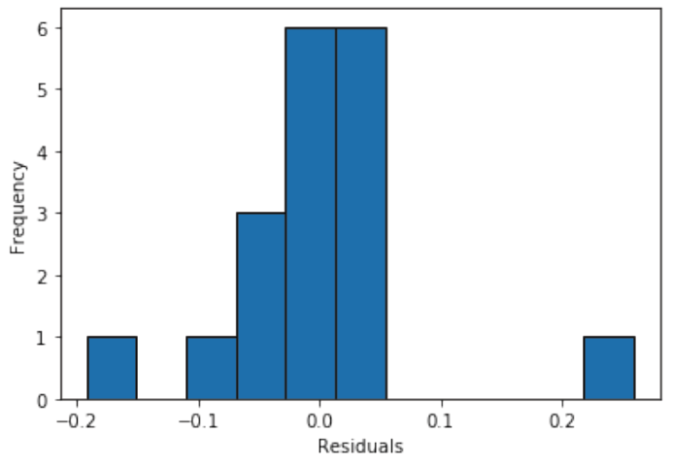
Table 1. Result of experiments
Model | Accuracy | Precision | Recall | F1-Score
RoBERTa Base | 0.9506 | 0.7938 | 0.7816 | 0.7876
RoBERTa Base +OSTI | 0.9544 | 0.8237 | 0.7773 | 0.7998
RoBERTa Large | 0.9506 | 0.7995 | 0.7722 | 0.7856
NukeLM | 0.9573 | 0.8270 | 0.8038 | 0.8152
SciBERT | 0.9548 | 0.8061 | 0.7910 | 0.7984
SciBERT + OSTI | 0.9532 | 0.8285 | 0.7747 | 0.8007
Equations should be placed flush-centre with the text margin and should be preceded and followed by one line of white. Equations should appear in line with the text, and should be numbered sequentially in parentheses on the right. The equation number should be flush with the right margin. The style “equation” includes a right tab to place the number correctly. For example:
(1)
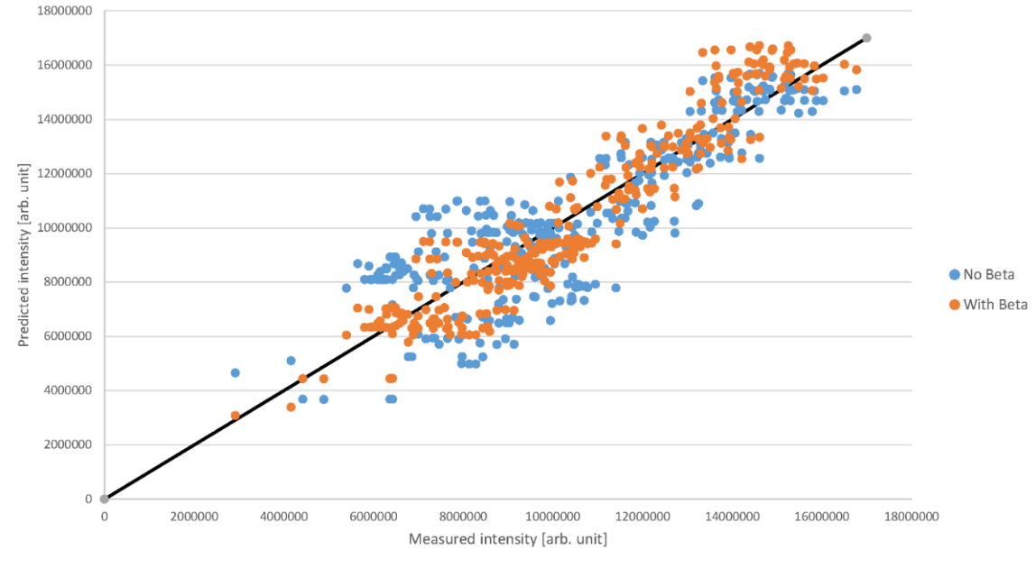
The normal size of variables within the equation should be 10 points, with appropriate changes in size for subscripts, superscripts, etc. You may use MathType for equations in your paper, as in the example above (1). A math object is any equation or fragment containing mathematical symbols (including Greek characters, superscripts and subscripts) that appears either in-line (in the flow of normal text) like for example or as a display equation (in its own space between lines of text) like Eq. (1). For long equations, the equation number may appear on the next line. For very long equations, the right side of the equation should be broken into approximately equal parts and aligned to the right of the equal sign.
Figure 2. Good quality with clear lettering. Caption alignment left of the figure.

In case of a single letter of the equation being referenced in the body text, use the Cambria Math font for that symbol. Here below the letters Y, J and x are represented using Cambria Math font. e.g.
…the parameters Y, J, and x…

Acknowledgments
Collate acknowledgements in a separate section at the end of the article before the references and do not, therefore, include them on the title page, as a footnote to the title or otherwise. List here those individuals who provided help during the research (e.g., providing language help, writing assistance or proof reading the article, etc.). Do not number this section.

References
The references should be brought together at the end of the article. Authors should check whether every reference in the text appears in the list of references and vice versa. The font size for the reference list should be 9pt. Please follow the style in the examples below for Journal references, Books, Edited Books, and Patents.
In the text - Number references sequentially in the text with square brackets, e.g ‘Jones [11] demonstrated that…….’ or as superscript numbers Williams has shown that ….¹.'
Please be consistent.
In the reference list – Order the references numerically, there is no need for brackets in the list. Do not order the references alphabetically in the reference list. This will result in non-sequential numbering in the text. The order should be as follows:

For books
- Surname, Initials (year). Title of Book. Place of publication: Publisher. e.g.
Harrow, B. (2009). Safeguards and more. London, UK: Simon & Schuster.

For book chapters
- Surname, Initials (year). Chapter title. In Editor's Surname, Initials, Title of Book (pages). Place of publication: Publisher. e.g.
Rossi, F.A. (2005). Non-Proliferation Treaty reviewed. Iin Stankosky, M. (Ed.), Pros and pros of the treaty (pp. 15-20). New York, NY: Elsevier.

For journals
- Surname, Initials (year). Title of article. Journal Name, volume(number), pages. e.g.
Capuzzi, M.T. and Fergus, R. (2005). Seals and dry cask analysis. ESARDA Bulletin – The International Journal of Nuclear Safeguards and Non-Proliferation, 22(2), pp. 72-80.

For published conference proceedings
- Surname, Initials (year of publication). Title of paper. In Surname, Initials (Ed.), Title of published proceedings which may include place and date(s) held (page numbers). Place of publication: Publication place. e.g.
- Martikka, E., Honkamaa, T., Karhu, P., Okko, O. (2007). Nuclear safeguards and security call for cooperation. 2007 ESARDA Symposium - 29th ESARDA Annual Meeting, Aix-en-Provence (France), 2007 (pp. 580 – 583). Luxembourg: Publications Office of the EU.

For working papers
- Surname, Initials (year). Title of article. Working paper [number if available]. Institution or organization. Place of organization, date. e.g.
- Moizer, P. (2003). How published academic research can inform policy decisions: the case of mandatory rotation of audit appointments. Working paper. Leeds University Business School, University of Leeds. Leeds, 28 March.
- Further documentation about the ESARDA Bulletin from https://esarda.jrc.ec.europa.eu/publications-0/esarda-bulletin_en.

Website
- Surname, Initials (publication date). Title of article. Institution or organization. Place of organization, date retrieved. e.g. Link
- Smith, J (March 8, 2020). Experts assess the nuclear Non-Proliferation Treaty, 50 years after it went into effect. Brookings Institution. Washington D.C., December 10, 2021. https://www.brookings.edu/articles/experts-assess-the-nuclear-non-proliferation-treaty-50-years-after-it-went-into-effect/

