ESARDA Formatting Guidelines for Authors

Bulletin – Authors First Author Name a, Second Author Name a, Third Author Name a, b, Fourth Author Name b, Fifth Author Name b, Sixth Author Name a

Bulletin – Affiliation a University Name, Faculty Group, Department, Street Address, City, Country, Postal Code

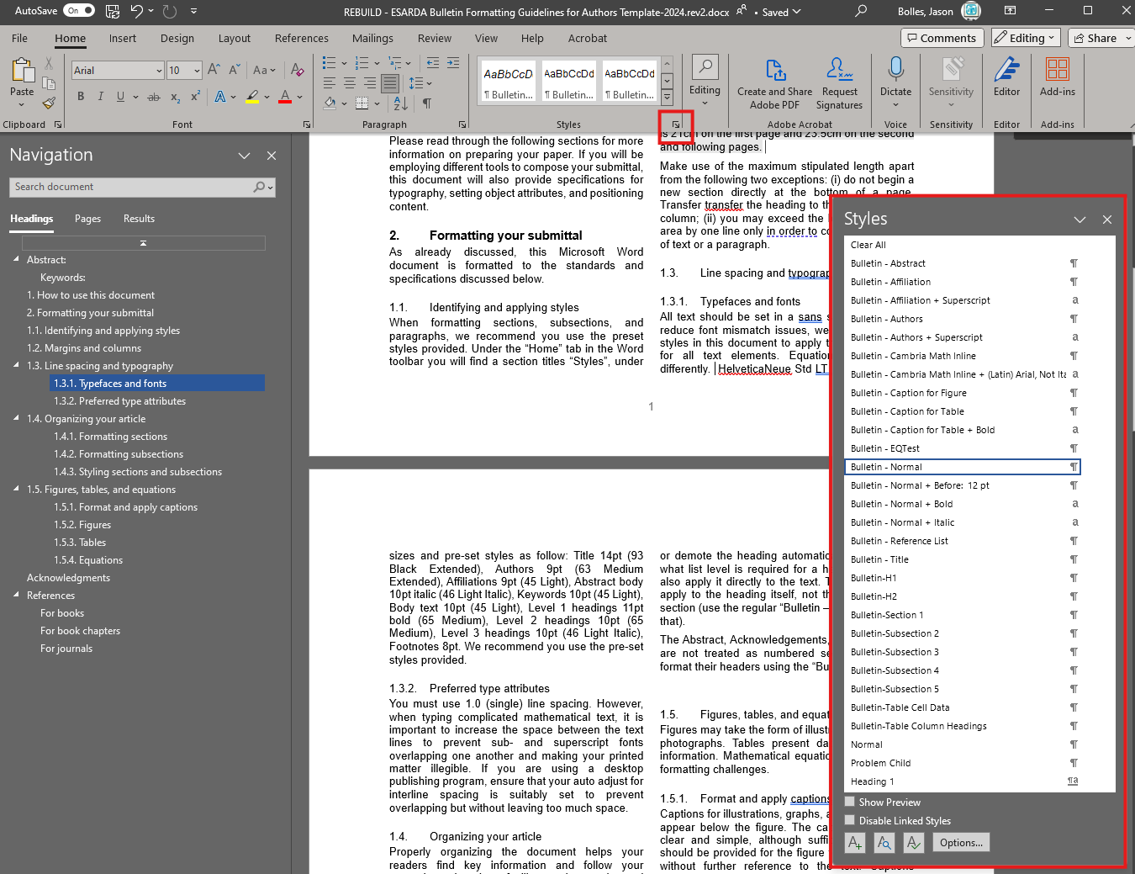Bulletin – Affiliation b Company Name, Street Address, City, Country, Postal Code

Abstract:

*The abstract should contain between 100 and 250 words. A concise and factual abstract is required. The abstract should state briefly the purpose of the research, the principal results and major conclusions. An abstract is often presented separately from the article, so it must be able to stand-alone. For this reason, References should be avoided, but if essential, then cite the author(s) and year(s). Furthermore, non-standard or uncommon abbreviations should be avoided, but if needed they must be defined at their first mention in the abstract itself.*

Keywords:

**Figure 1**. Microsoft Word style palette for this template.

Keyword1, Keyword2, Keyword3 (Please select a maximum of 6 keywords)

1. How to use this document

Using this guidance document as a template will enable you to prepare your paper for submittal to the ESARDA Bulletin with minimal manual styling and formatting. Such properties as page size, column placement, column size, and section formatting will already be resolved. Paragraph and text style presets are also provided.

Please read through the following sections for more information on preparing your paper. If you will be employing different tools to compose your submittal, this document will also provide specifications for typography, setting object attributes, and positioning content.

1. Formatting your submittal

As already discussed, this Microsoft Word document is formatted to the standards and specifications discussed below.

* 1. Identifying and applying styles

When formatting sections, subsections, and paragraphs, we recommend you use the preset styles provided. Under the “Home” tab in the Word toolbar you will find a section titles “Styles”, under which you can bring up a “Styles” pane on the right-hand side of your window. The style pane that lists presets you may apply to selected text (Figure 1).

To identify what style in the pane is applied to a given section of text, simply highlighting a block of text in the Word file with the Styles Pane open. The relevant style for that text will be highlighted within the pane. If multiple paragraphs using different styles are selected, the pane will only highlight the first contiguous block selected. If no style is applied to a given block of text, the default Microsoft style—"Normal” —will be highlighted.

This guidance document employs a dedicated style set. All styles relevant to this document appear in the style pane prefixed by the word “Bulletin” with a parent style named “Bulletin – Normal”.

* 1. Margins and columns

Should you choose to build a document using different tools, please set all margins at 2.54cm.

The Bulletin title, bulletin authors, and author affiliations should span both columns of the document. The rest of document’s copy and figures must be set into a two-column layout. Each column must be 8.47 cm wide with a 0.85 cm gutter (middle margin) for a total width of 17.78 cm. The maximum length of columns is 21cm on the first page and 23.5cm on the second and following pages.

Make use of the maximum stipulated column length apart from the following two exceptions: (i) do not begin a new section directly at the bottom of a page. Transfer the heading to the top of the next column; (ii) you may exceed the length of the text area by one line only to complete a section of text or a paragraph.

* 1. Typography and line spacing

Unless special considerations exist (e.g., equations), You must use a sans-serif typeface and 1.0 (single) line spacing in your submittal. The preferred typeface for the ESARDA bulletin is Helvetica Neue, but Arial is more broadly available and poses fewer licensing issues.

* + 1. Typefaces and fonts

To reduce font mismatch issues, we have set all the styles in this document to apply the Arial typeface under the parent style “Bulletin – Normal”. We recommend using the pre-set styles provided in this document, the core attributes of which are listed under Table 1.

**Table 1**. Hierarchical list of main ESARDA bulletin styles

| Style Name | Typeface/Font | Point size |
| --- | --- | --- |
| Bulletin – Normal | Arial/Regular | 10 |
| Bulletin – Title | Arial/Bold | 14 |
| Bulletin – Authors | Arial/Regular | 9 |
| Bulletin – Affiliation | Arial/Regular | 9 |
| Bulletin – H1 | Arial/Regular | 11 |
| Bulletin – H2 | Arial/Bold | 10 |
| 1. Bulletin-H1 Section | Arial/Regular | 11 |
| 1.1 Bulletin-H2 Subsection | Arial/Regular | 10 |
| 1.1.1 Bulletin-H3 Subsection | Arial/Regular | 10 |
| 1.1.1.1 Bulletin-H4 Subsection | Arial/Regular | 10 |
| 1.1.1.1.1 Bulletin-H5 Subsection | Arial/Regular | 10 |
| Bulletin – Reference List | Arial/Regular | 10 |

Figures, equations, and tables are handled differently than copywritten blocks. More information on those objects is available under section 1.5.

* 1. Organizing your article

Properly organizing the document helps your readers find key information and follow your reasoning. It also facilitates better internal referencing.

* + 1. Formatting sections

Divide your article into clearly defined and numbered sections. Use this numbering also for internal cross-referencing: do not just refer to "the text". Any section may be given a brief heading. Each heading should appear on its own separate line.

* + 1. Formatting subsections

Subsections should be numbered 1.1 (then 1.1.1, 1.1.2, ...), 1.2, etc. Any subsection may be given a brief heading. Each heading should appear on its own separate line.

* + 1. Styling sections and subsections

This document includes a custom multi-level list tied to the “Bulletin-Section 1” and “Bulletin-Subsection [2-5]” styles that will automatically format and increment the numbering scheme of a given section or subsection heading. The multilevel list structure runs 5 levels deep and is labeled H1 through H5, respectively.

Highlighting the entire section or subsection heading and hitting TAB or SHIFT+TAB will promote or demote the heading automatically. If you know what list level is required for a heading, you may also apply it directly to the text. These styles only apply to the heading itself, not the content of the section (use the regular “Bulletin – Normal” style for that).

The Abstract, Acknowledgements, and References sections are not treated as numbered sections. You can format their headers using the “Bulletin – H1” style. A non-numbered subhead (“Bulletin – H2”) is also available for use.

* 1. Figures, tables, and equations

Figures may take the form of illustrations, charts, or photographs. Tables present data and organize information. Mathematical equations pose specific formatting challenges. Caption styles for these objects are provided under Table 2.

* + 1. Format and apply captions

Captions for illustrations, graphs, and charts should appear below the figure. The captions should be clear and simple, although sufficient information should be provided for the figure to be understood without further reference to the text. Captions should be 9 point HelveticaNeue Std LT font, left aligned with the figure, and have 6pt spacing after and 6pt before the captions. The words “Fig. 1.” should be in bold as shown in the example figure in this document.

* + 1. Figures

Figures must be of good quality at the highest possible resolution. Blurred or pixelated images will not be accepted.

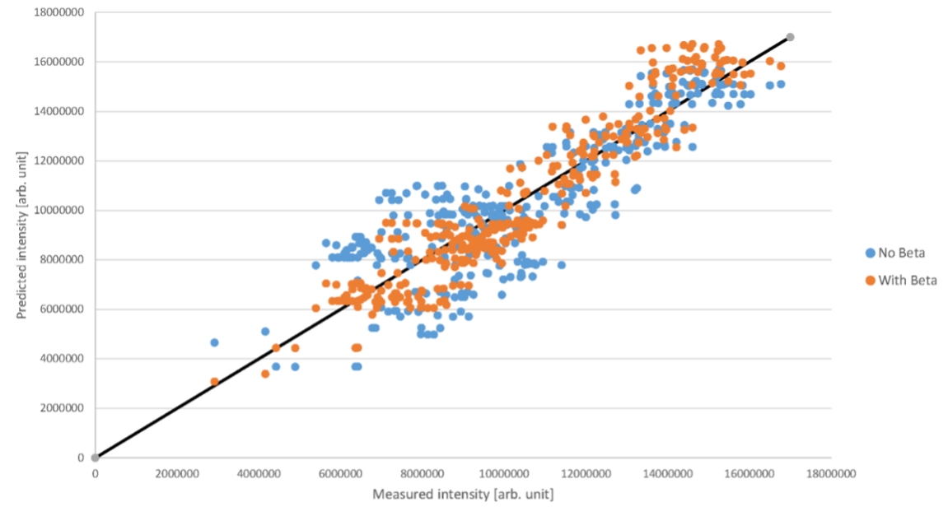All illustrations should be clearly displayed by leaving at least a single line of spacing above and below them. When placing a figure at the top of a page, the top of the figure should be at the same level as the first text line of the other column. Legends to illustrations should be centered if on one line or aligned left if on two or more lines. Figures and graphs should also be large enough for the figure to be clear.

**Figure 2.** A quality chart spanning both columns. Note the placement of the legend.

Text within figures must be a sans serif font appropriate for the figure. Arial or Helvetica are ideal. Font sizes for legends should be 8pt (to be legible). Figure captions should appear below the figure. The captions should be clear and simple, although sufficient information should be provided for the figure to be understood without further reference to the text. Captions should be set at a 9 point font size, and set 6pt spacing both above and below their boundary box. The words “Fig. x.” should be in bold as shown in the example figure in this document. The caption should end with a full stop. You can also span both columns for large figures (Figure 2).

* + 1. Tables

Tables should include a title that explains the table and its data without requiring a reference to the text. Tables should be presented in the form shown in Table 1, with all text, including title 9pt. Their layout should be consistent throughout. Horizontal lines should be placed above and below table headings, above the subheadings and at the end of the table above any notes. Vertical lines should be avoided. Table borders should be simple ½ point lines (no double or bold lines). The header row of the table should be in bold type, not italic. If a table is too long to fit onto one page, the table number and headings should be repeated on the next page before the table is continued. Alternatively, the table can be spread over two consecutive pages (first on even-numbered, then on odd-numbered page). Table captions should appear above the table (see Table 1).

**Table 2**. Hierarchical list of ESARDA styles for inline bulletin figures, tables, and equations.

| Style Name | Typeface/Font | Point size |
| --- | --- | --- |
| Bulletin - Equation |  |  |
| Bulletin – Caption for Table | Arial/Regular | 9 |
| Bulletin – Caption for figure | Arial/Regular | 9 |
| Bulletin – Table Column Headings | Arial/Bold | 9 |
| Bulletin-Table Cell Data | Arial/Regular | 9 |

The captions should be clear and simple, although sufficient information should be provided for the table to be understood without further reference to the text. Captions should be set in a 9-pt sans serif type and centered above the table with 6pt spacing before and after the captions. The words “Table 1” should be in bold as shown in the example figure in this document. The caption should end with a full stop. You can also span both columns for large tables in the same fashion as the earlier example from Fig. 1.

* + 1. Equations

Equations should be placed flush-centre with the text margin and should be preceded and followed by one line of white. Equations should appear in line with the text and should be numbered sequentially in parentheses on the right. The equation number should be flush with the right margin. The style “equation” includes a right tab to place the number correctly. For example:

(1)

While you must use 1.0 (single) line spacing for normal copywriting, exceptions must be applied to complicated mathematical text. Be sure to increase the space between the text lines to prevent sub- and superscript fonts overlapping one another and making your printed matter illegible. If you are using a desktop publishing program, ensure that your auto adjust for interline spacing is suitably set to prevent overlapping but without leaving too much space.

The normal size of variables within the equation should be 10 points, with appropriate changes in size for subscripts, superscripts, etc. You may use MathType for equations in your paper, as in the example above (1). A math object is any equation or fragment containing mathematical symbols (including Greek characters, superscripts and subscripts) that appears either in-line (in the flow of normal text); for example or as a display equation (in its own space between lines of text) like Eq. (1). For long equations, the equation number may appear on the next line. For very long equations, the right side of the equation should be broken into approximately equal parts and aligned to the right of the equal sign.

In case of a single letter of the equation being referenced in the body text, use the Cambria Math font for that symbol. Here below the letters Y, J and x are represented using Cambria Math font. e.g.

…the parameters Y, J, and x…

Acknowledgments

Collate acknowledgements in a separate section at the end of the article before the references and do not, therefore, include them on the title page, as a footnote to the title or otherwise. List here those individuals who provided help during the research (e.g., providing language help, writing assistance or proofreading the article, etc.). Do not number this section with a multilevel list style; use the style “Bulletin-H1” style instead.

References

The references should be brought together at the end of the article. Authors should check whether every reference in the text appears in the list of references and vice versa. The font size for the reference list should be 9pt. Please follow the style in the examples below for Journal references, Books, Edited Books, and Patents.

For books

[#] Surname, Initials (year). Title of Book. Place of publication: Publisher.

For example:

[1] Harrow, B. (2009). Safeguards and more. London, UK: Simon & Schuster.

For book chapters

[#] Surname, Initials (year). Chapter title. In Editor's Surname, Initials, Title of Book (pages). Place of publication: Publisher.

For example:

[2] Rossi, F.A. (2005). Non-Proliferation Treaty reviewed. Iin Stankosky, M. (Ed.), Pros and pros of the treaty (pp. 15-20). New York, NY: Elsevier.

For journals

[#] Surname, Initials (year). Title of article. Journal Name, volume(number), pages.

For example:

[3] Capuzzi, M.T. and Fergus, R. (2005). Seals and dry cask analysis. ESARDA Bulletin – The International Journal of Nuclear Safeguards and Non-Proliferation, 22(2), pp. 72-80.